**Project Design Phase-II**

**Technology Architecture**

|  |  |
| --- | --- |
| Date | 16 October 2022 |
| Team ID | PNT2022TMID16755 |
| Project Name | Data Analytics for DHL Logistics Facilities |
| Maximum Marks | 4 Marks |

**Technical Architecture:**

Technical architecture software meets business needs and expectations while providing a strong technical plan for the growth of the software application through its lifetime. Technical architecture is important to both the business team and the information technology team

**Diagram:**

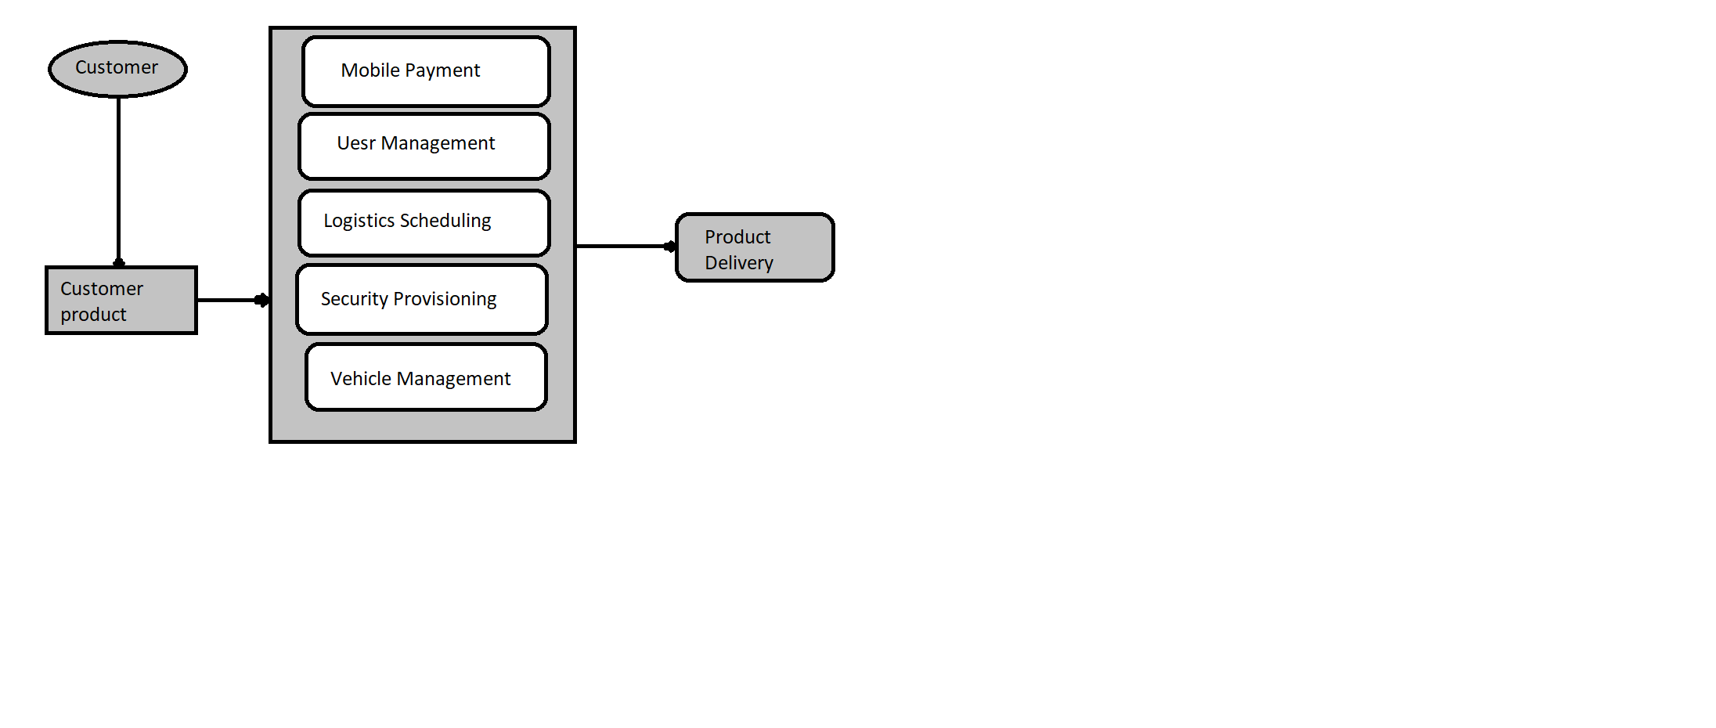

|  |  |  |  |
| --- | --- | --- | --- |
| **S.No** | **Component** | **Description** | **Technology** |
|  | Cloud Database | Database Service on Cloud | IBM DB2, IBM Cloudant etc. |
|  | File Storage | File storage requirements | IBM Block Storage or Other Storage Service or Local Filesystem |
|  | External API-1 | Purpose of External API | IBM Weather API, etc. |
|  | External API-2 | Purpose of External API | Aadhar API, etc. |
|  | Machine Learning Model | Purpose of Machine Learning Model | Object Recognition Model, etc. |
|  | Infrastructure (Server / Cloud) | Cloud  Local Server Configuration:  Cloud Server Configuration : | Local, Cloud Foundry, Kubernetes, etc. |